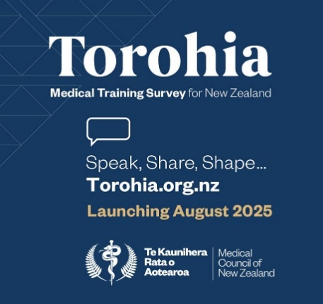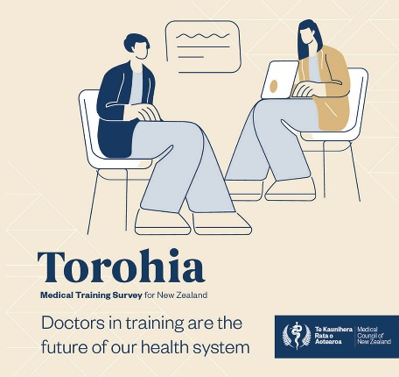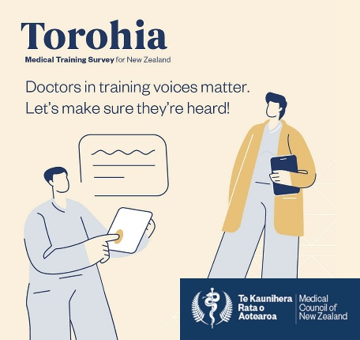**Toolkit social media posts  
  
Post image options** (any can be used as the web tile)

**Text options**  
We’re backing Torohia, Aotearoa New Zealand’s first national survey for doctors in training developed by @Medical Council of New Zealand. Launching 18 August, it’s our chance to hear directly from those shaping our health workforce.

Why it matters— Torohia will offer vital insights into supervision, support, and training experience — helping improve retention and wellbeing of doctors across Aotearoa New Zealand. A strong response will help identify what’s working well, what needs improving, and how we can support change that works for doctors and for patients.

Let’s get behind it:  
  
**🔗** Visit the website: [www.torohia.org.nz](https://www.torohia.org.nz/)   
🔗 Download the toolkit: [www.torohia.org.nz/promo-kit](https://www.torohia.org.nz/promo-kit)

Want to help improve medical training in Aotearoa? Start here!

@Medical Council of New Zealand is launching Torohia, Aotearoa’s new national survey for doctors in training. The supporter toolkit is now live — packed with resources to help you raise awareness before the 18 August launch.

What’s inside:  
 **•** Posters + virtual backgrounds  
• Social media video and images

• Newsletter copy + explainer video  
• Plain-language factsheet

• Presentation about Torohia

Let’s help trainee doctors feel supported — and heard.

Download the toolkit: [www.torohia.org.nz/promo-kit](https://www.torohia.org.nz/promo-kit)